LESSON 1
Content Practice A
Understanding Science
Directions: Complete the crossword puzzle with the correct terms from the word bank.

hypothesis | inference | observation | prediction
scientific law | scientific theory | technology

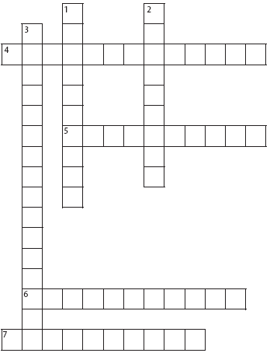

Across
4. describes a pattern or an event in
nature that is always true
5. the practical use of scientific
knowledge, especially for industrial or
commercial use
6. using one or more senses to gather
information and notice what occurs
7. a possible explanation about an
observation that can be tested by
scientific investigations
Down
1. a statement about what will happen
next in a sequence of events
2. a logical explanation of an observation
that is drawn from prior knowledge or
experience
3. an explanation of observations or
events based on knowledge gained
from many observations and
investigations

Scientific Explanations 9
Name Date Class
LESSON 1
Content Practice B
Understanding Science
Directions: On the line before each question, write L if the question might be asked by a life scientist, E if the
question might be asked by an Earth scientist, or P if the question might be asked by a physical scientist.
1. How do rocks form?

2. How does an object’s motion change?

3. What substances are in soil?

4. Why does a liquid change to a solid?

5. How do plants produce their own food?

6. Why do some animals give birth to live young and others lay eggs?

7. How are force and motion related?

8. How are reptiles and birds related?

9. What causes earthquakes?
Directions: Answer each question or respond to each statement on the lines provided.

10. What is science?

11. Give an example of how you can use scientific inquiry to solve a real-life problem.

