With your own paper
- Fold the paper in half “hotdog” style to the margin of the paper, so you still have holes to clip it in your notebook later.
- Cut the paper so that it has 4 flaps.
- First Flap Major Function of Digestive system
- Second Flap Major Organs of Digestive system
- Third Flap Digestive system interact with other systems (at least 4 system)
- Fourth Flap Digestive system disorders

Main Function; The function of the digestive system is digestion and absorption. Digestion is the breakdown of food into small molecules, which are then absorbed into the body.
The major parts of the digestive system:
- Salivary glands.
- Pharynx.
- Esophagus.
- Stomach.
- Small Intestine.
- Large Intestine.
- Rectum.
- Accessory digestive organs: liver, gallbladder, pancreas.
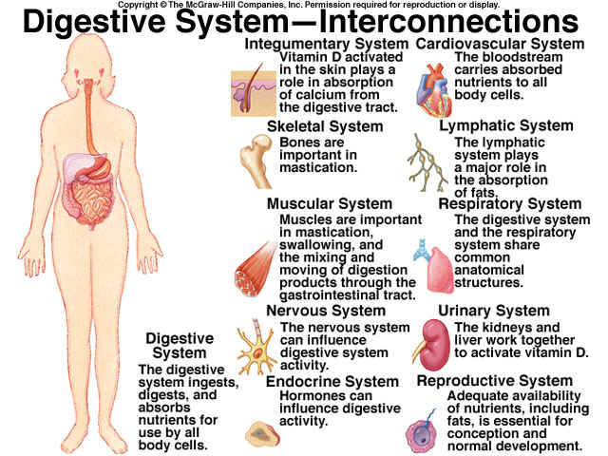

Digestive Disorders Overview
Common digestive problems include heartburn/GERD, IBD, and IBS.Symptoms may include bloating, diarrhea, gas, stomach pain, and stomach cramps

