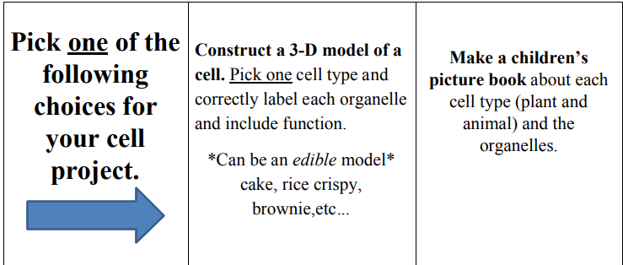
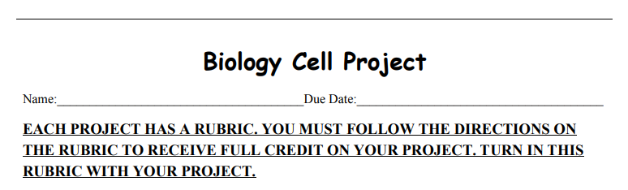

CHOICE​ ​1:​ ​ ​3-D​ ​Model​-​Pick​ ​animal​ ​OR​ ​plant​ ​cell.​ Make sure to label each organelle clearly. Be creative with your model by using everyday materials (Peanut shells, yarn, pennies, folded pipe cleaners, candy, shoeboxes, playdoh etc.) to represent the organelles. MUST​ ​include​ ​organelles​ ​for​ ​your​ ​cell​ ​type​ ​(plant​ ​or animal).​ Example, don’t include a chloroplast if you have an animal cell because only plant cells have those!!! MUST​ ​include​ ​organelle​ ​list​ ​and​ ​functions​ ​of​ ​each​ ​organelle​ ​you​ ​used.​ Model projects must be brought to Ms. Ilbay’s first period on the due date. Cakes and any perishable projects are graded FIRST. Once your project is graded (check with Ms. Ilbay FIRST), you may take it home or to the cafeteria to enjoy! :) You do not have to share with others if you don’t want too.
CHOICE​ ​2:​ ​ ​Children’s​ ​Picture​ ​Book​-​Must be about plant AND animal cells along with the organelles listed on the rubric. Think about how you would teach a child about cells and the organelles. Be creative with your drawings (can be printed or hand drawn) and your story! Stories created with Powerpoint will be accepted. Share with my email at ailbay@tmsacharter.org Late​ ​projects​ ​turned​ ​in​ ​will​ ​be​ ​deducted​ ​10​ ​points​ ​for​ ​each​ ​day​ ​late.​ ​No​ ​cakes/perishable​ ​accepted​ ​late.

