|  |  |
| --- | --- |
| **Aim 5.3: Net force** | **Name: _____________________** |

net force = **_________________________________________________________________________________________**

*Examples:*



1. When two or more forces are acting on the same object in the SAME direction, you ADD the forces.

25N → + 20N → = ________



1. When two or more forces are acting on the same object in OPPOSITE directions, you subtract the forces.

12N→

– 10N←

**When forces are BALANCED, they ______________________________________________________________________  
__________________________________________________________________________________________**

1. A big trailer pulls a box 400 N to the left and a little trailer pulls   
   the box 200 N to the right. What is the net force?   
   Is it balanced or unbalanced?  
     
   net force = _________________  
     
   __________________________
2. In the following examples, the people are all pushing books. Determine the net force of each and tell if the forces are balanced or unbalanced. If it is unbalanced use an arrow in the greater direction to show this.



10N 🡪 🡨 15N 20N 🡪 🡨 1N

**Independent practice:**

1. If a person pulls on a cart to the right with a force of 10N and another person pulls to the left with a force of 3N, what is the net force? Is it balanced or unbalanced?

3 N 10 N

net force = _____  
____________________________

Which direction would the cart move? _____________

1. If a person pulls on a cart to the right with a force of 5N and another person pulls to the left with a force of 15N, what is the net force? **Draw direction arrows.** Is it balanced or unbalanced?

15 N 5 N

Draw direction arrows!

net force = _____  
______________________________

How could the two people make their forces balanced? _____________________________________________

1. If a person pulls on a cart to the right with a force of 7 N and another person pulls to the left with a force of 13 N, what is the net force? Is it balanced or unbalanced? Label picture with direction arrows and numbers.

net force = _______  
____________________________

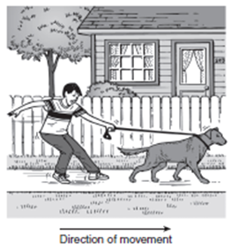How could the two people make their forces balanced? _____________________________________________

1. **TAKS Check:** In the picture on the right, a boy is trying to pull a dog on a leash, but the dog and the boy are moving in the same direction. Which of the following best describes the forces in this situation?
   1. The forces are balanced, and the net force is zero.
   2. The forces are unbalanced, and the boy’s force is greater.
   3. The forces are unbalanced, and the dog’s force is greater.
   4. The forces are balanced, and the dog is stronger than the boy.

**Show you’re TAKS ready by explaining your answer:**