2017-2018
STEM FAIR GUIDE

TRIAD MATH AND SCIENCE ACADEMY
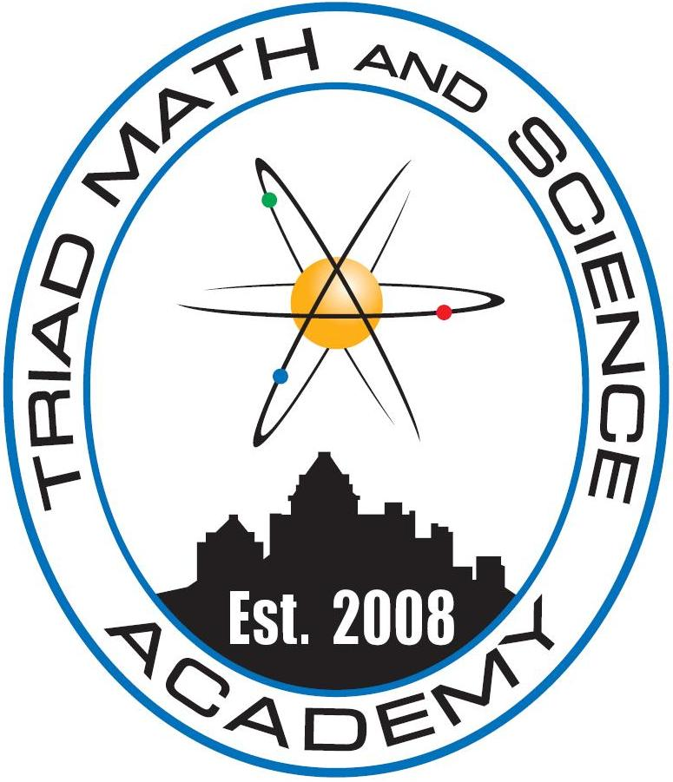

Triad Math and Science STEM Fair Project Guide
Your student will have the chance to solve his or her own science mystery by doing a science project for the TMSA STEM fair, a mandatory assignment for your child’s class.

2017-2018 Academic School Year
Dear Parents,
Your student will have the chance to solve his or her own science mystery by doing a science project for the TMSA STEM fair, a mandatory assignment for your child’s class.
Since your student has the chance to pick his or her own science project question, from the physics of making music to the biology of tide pool animals, he or she will have the chance to experience the joy of discovery. When your student starts a science project, he/she will choose a question they would like to answer. Then they will do the research in the library or internet to gain the background information needed to express a hypothesis and design an experimental procedure. After writing a report to summarize the background research, the student will perform the experiment, draw conclusions, and communicate the results to teachers and classmates.
Through time management and project planning, your student will take on the responsibility of completing a project over a minimum of 10 weeks. Your student will discover his or her creativity by brainstorming science project questions and figuring out how to display the scientific process and results. A science project is to ask questions and discover the answers. This is very similar to what all scientists do in their careers.
TMSA will provide your student with sufficient support to succeed as this is part of your student’s grade. Teachers will start off with homework assignments, and then we will review the assignments at key checkpoints along the way to make sure your student is on the right track. Secondly we have included in our packets a guide of how to help without taking over your student’s project.
Please see attached the form to sign and approve the project your student has selected. If you have any questions please email:
- Mr. Kelleci at ekelleci@tmsacharter.org for the grades 6th through 12th
- Mr.Ilbay at ailbay@tmsacharter.org for the 7th grade
Sincerely,
Dr. Taysever,
Director
Included:
A Parent’s Guide to TMSA STEM Projects
Student STEM Fair Project Schedule
Parent Signature

